CHRISTMAS TREE LIGHTING CEREMONY
Thursday, November 30, 2017
6:30 PM at the gazebo
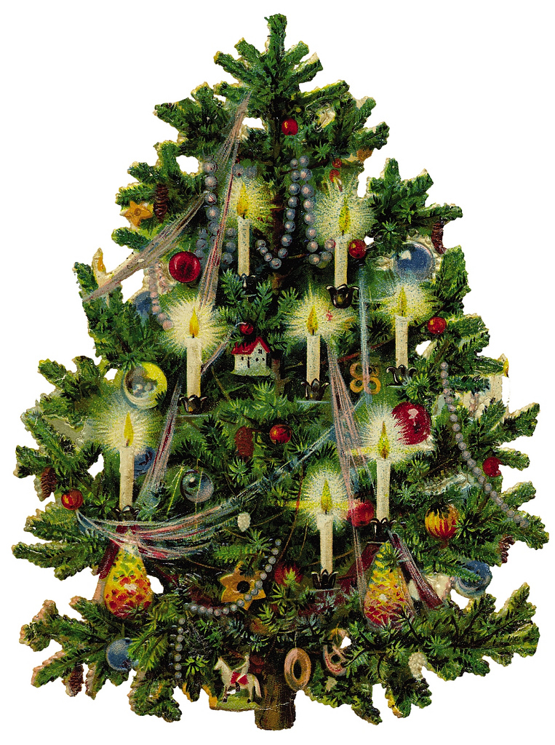

JOIN US FOR CAROLS, COCOA & COOKIES

